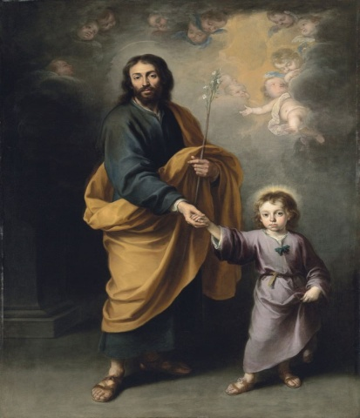
After watching Video #1, prayerfully read the following passage from Luke 1:18-24
Now this is how the birth of Jesus Christ came about. When his mother Mary was betrothed to Joseph, but before they lived together, she was found with child through the Holy Spirit.
Joseph her husband, since he was a righteous man, yet unwilling to expose her to shame, decided to divorce her quietly.
Such was his intention when, behold, the angel of the Lord appeared to him in a dream and said, “Joseph, son of David, do not be afraid to take Mary your wife into your home. For it is through the Holy Spirit that this child has been conceived in her.
She will bear a son and you are to name him Jesus because he will save his people from their sins.”
All this took place to fulfill what the Lord had said through the prophet:
“Behold, the virgin shall be with child and bear a son,
and they shall name him Emmanuel,”
which means “God is with us.”
When Joseph awoke, he did as the angel of the Lord had commanded him and took his wife into his home.

Ponder the following:
What was going on within Joseph when he found Mary pregnant? How does the “reverence theory” apply here? When in my life have I felt overwhelmed by something hard to understand God has allowed to happen, but still chosen to trust his plan?
Reflect on this wholehearted surrender of his sexuality that Joseph found so fruitful, to where he was even given the honor to name the child. When has my “yes” been conditioned by someone else’s “yes”, as Joseph’s was by Mary?
How did Joseph’s complete self-gift influence his own son Jesus, who chose to follow St. Joseph’s example? How am I called, like Joseph, to be a model for others to imitate in my own life of self-gift?
Be open to ponder and meditate whatever else comes to mind from this passage or from our video reflection.
Close with a colloquy/dialogue from the heart to St. Joseph.
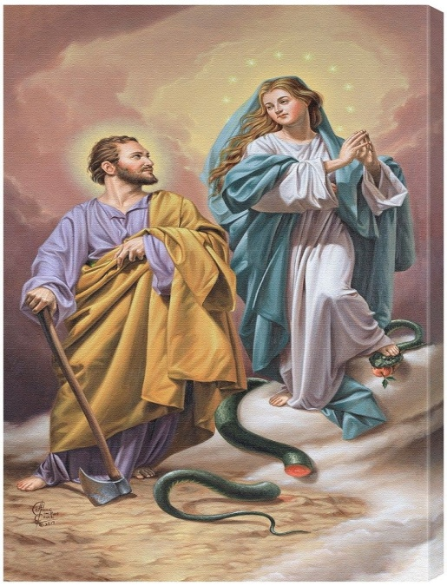
After watching Video #2, ponder the following questions, using your imagination, which build upon the stories of Scripture:
How did St. Joseph see Mary as tabernacle of the Most High? How did he perhaps perceive the divine working within her? Did he perceive those divine cells within her she received from Jesus? How did they touch one another and support one another? How do I see Mary as the new Ark of the Covenant, holding the most precious things of God? How do I feel her touch?
What was the level of intimacy between St. Joseph and Jesus? How did they joke with one another? What was it like for them to sweat over wood or stone together? What did Joseph like about the way Jesus smiled, walked, sneezed? How did they talk to one another?
Jesus is called “the carpenter’s son” by others of that time. What did that mean for Jesus? Did he take it as a compliment? Was he proud to have learned stone working and wood working from Joseph? Was it hard for him to leave that task when his public ministry began?
Close with a colloquy/dialogue from the heart to either Mary or St. Joseph or both.

